May 8, 2019
Environmental Advisory Committee and River Systems Advisory Committee

Item | 71 Wyndham Street South Environmental Implementation Report (EIR)
Proposal | An EIR ToR is proposed to help fulfill Condition 18 of the OPA and ZBA to permit the development of 14 storey apartment building with 140 units, a ground floor commercial unit and three levels of underground parking.
Location | The subject property is located directly adjacent to the Speed River south of Wellington Road East, on Wyndham St South. (see Attachment 1)
Background |  | - The lands fall entirely within the Speed River Watershed and are within the Downtown Secondary Plan Area.  - OPA/ZBA approval was granted in September through Council approval of IDE-2018-109.  - The site has been re-zoned from CR-7 (Specialized Commercial-Residential Zone) to D.1-29(H) (Specialized Downtown 1 Zone) and FL (Floodway Zone).  - The OPA allowed four additional storeys to be added through bonusing and larger floorplates than generally permitted in the Downtown Secondary Plan. The bonusing agreement entails a cash contribution towards acquiring riverfront parkland, with the contribution value based on 25% of the increase in land value for the additional 4 storeys permitted on site.  - The FL zone on and adjacent to the site contains Significant Natural Area corresponding to: Surface Water and Fish Habitat, Significant Valleylands, Significant Wildlife Habitat (Waterfowl Overwintering Habitat) and their buffers.  - The EIS in support of the OPA/ZBL was supported with conditions.  - EAC supported the EIS prepared by Stantec (dated October 30, 2017) at the December 2017 meeting with the following conditions:  - THAT confirmation that there are no structures in the floodway is provided through drawings prior to approval of the application.  - THAT additional information is provided to inform and illustrate the hydrogeological conditions as part of the Hydrogeological Assessment  - THAT an Environmental Implementation Report (EIR) is prepared prior to Site Plan Approval that includes:  - A detailed and updated Tree Inventory Preservation Plan;  - How mitigation measures are incorporated to ensure no negative impacts;  - A detailed restoration plan for the floodway which includes trail design, water quality and quantity improvements, consideration for biodiversity enhancements, pollinator habitat, improving habitat for significant species, invasive species management, vegetation management, management of human-wildlife conflict, educational signage and removal of debris and refuse;  - Mapping depicting the top-of-bank, buffer and the appropriate building setback from the natural heritage system;  - A detailed during-construction monitoring plan including the typical requirements and a detailed post-construction monitoring plan which includes bird strike mitigation effectiveness, stormwater outlet monitoring and restoration monitoring;  - Stormwater Management Design and Erosion and Sediment Control Plans;  - Exploration of LID/greywater recovery system opportunities;  - An Environmental Management and Monitoring Plan to assist in ensuring no impacts to the Natural Heritage System from the dewatering activities.  - Condition 18 of the OPZ/ZBL approval:  - Prior to Site Plan approval, tree removal and/or site alteration, the developer shall prepare an Environmental Implementation Report (EIR), based on a Terms of Reference approved by the City and the Grand River Conservation Authority, to the satisfaction of the General Manager of Planning, Urban Design and Building Services. The EIR must at minimum include a description of the proposed development and details as to how the mitigation plan meets the conditions of approval and any other specialized requirement to protect the natural environment. Specifically, the EIR should include an analysis of habitat for significant species, a detailed Restoration Plan for the floodway lands which considers biodiversity enhancements, detailed Natural Heritage System mapping, a Stormwater Management Design that considers additional LIDs, an Environmental Management Plan that addresses dewatering during and post construction including a visual representation of the potential zone of influence, and a detailed erosion and sediment control plan.  - Confirmation of no structures in the floodway other than the stormwater outlet will be undertaken by staff during site plan review.  - Subsequent to EAC’s support, the development was redesigned to include additional underground parking with excavation to 9.2 mbgs to eliminate the above ground parking consistent with urban design objectives. Excavation to 2.2 mbgs was previously proposed.  - Additional hydrogeological information was provided in April 2018 to support the proposal including the redesign. Peer and staff review was undertaken on this material.  - GRCA has reviewed the EIR and provided comments (see Attachment 2)  - Parks Planning have reviewed the EIR and provided comments (see Attachment 3)
Comments | Staff have reviewed the Environmental Implementation Report (EIR) prepared by Stantec dated March 25, 2019 and have the following comments:  General: Several items from the approved Terms of Reference were not provided in the report. Revise to include the following:  - Discussion of green roof and greywater recovery system and where those technologies may be feasible.  - Recommended mitigation for storm/sanitary/watermain servicing installations relative to groundwater impacts.  - Results of a Request for Review by Fisheries and Oceans Canada or a Self-Assessment and associated mitigation measures to protect fish and fish habitat (note that the report indicates that this item was under separate cover but it was not provided).  - Post development NHS digital information that clearly illustrates all Significant Natural Areas and the floodway line in AutoCAD, ESRI shapefile, or ESRI geodatabase formats as well as complete wildlife lists in digital format.  - A Checklist Summary Table outlining commitments through the construction and monitoring phases.  Section 2.5 Wildlife and Wildlife Habitat: A Snapping Turtle was documented attempting to make a nest in the parking lot in June 2015. Revise to include this observation.  Section 4.2 Tree Preservation and Compensation: The Tree Preservation Plan was not updated and includes an outdated trail alignment. Additionally, the grading plan displays the TPF in a slightly different location. Confirm that the plan is still appropriate or revise accordingly and ensure consistency between plans.  Section 4.3 Restoration and Enhancements: The restoration plan does not fulsomely consider the site. The existing parking lot extends to the lot line and gravel/fill/debris has been pushed outside the lot line into the riparian zone. However, the grading plan only extends to the Tree Protection Fencing (TPF). While this is typically appropriate, given the existing impacts the restoration plan should seek to fulsomely rehabilitate the area including the following:  - Full removal of the parking lot substrate and replacement with topsoil.  - Consideration to include turtle nesting habitat.  - Appropriate plantings conditions for the plantings proposed beyond the TPF.  - Consideration for work outside the subject property including fill/refuse removal and invasive tree, shrub and herbaceous removals. Without removal, their presence threatens the success and integrity of the restoration plantings.  While removal of buckthorn is recommended in the report, this has not been included on the plans. To ensure proper implementation, the plans must detail all restoration elements. This activity should be coordinated with the hazard tree removal outlined in the report and the invasive tree removal discussed above.  Revise the landscape plans to address the following:  - Amelanchier canadensis is considered non-native in Ontario and should be replaced with a native species. Consider A. laevis or A. arborea.  - Viburnum trilobum is not recommended for use because nurseries often confuse/replace with the similar non-native, invasive species.  - Sorghastrum pectinata is an unknown species.  - The educational signs should be revised to reflect the finalized plantings as needed. It is not clear why notes on bats and oak trees have been included considering no oak trees are currently present and the three oaks provided on the plans will take decades before they provide maternal roosting opportunities (cavities). Additionally, the location of the signs must be identified on the landscaping plans to ensure proper implementation.  Currently, only basic trail development is proposed with final trail implementation to be completed at a later date. To prevent impacts to the restoration areas, it is recommended that full trail development take place during the restoration of the site. Alternatively, the EIR must explain how final trail development can occur without negative impacts.  Section 4.4 Building Design – Bird Friendly Guidelines: It is not clear that appropriate mitigation has been fulsomely included. The City of Toronto’s guidelines referenced in the report contains the Toronto Green Standard on page 35. This building design should meet this standard and the EIR should demonstrate how that has been done.  Section 6.2.2 Turtle Nesting: Revise this section to include the Snapping Turtle observation outlined above and appropriate mitigation in the event that exclusion fencing is not implemented prior to nesting season.  Section 6.3 Erosion and Sediment Control Plan: The plan must be revised to include measures for the construction of the stormwater outlet. Additionally, it should be revised to consider the full removal of the parking lot and associated fill outlined above.  Section 6.4 Construction Dewatering: This section indicates that the bedrock surface may not intercept the river near the subject property. However, Section 2.2.1 indicates discusses exposed bedrock in the river and it appears that bedrock is visible on aerial photography. This should be revised as appropriate including any relation to the pumping estimates and potential impacts on the Speed River. Additionally, this section should expand on the proposed waterproof base that is will prevent the need for permanent dewatering. It is our understanding that many waterproofing treatments exist with differing levels of impermeability.  Section 7 Monitoring Program: It is not clear how the data from the level loggers will be obtained in order to inform the Environmental Management Plan. Ideally, telemetry would be used to inform decision making relative to identified triggers in real-time. At minimum, a robust download and analysis program must be recommended in the report. The report indicates that the development of triggers will be done in the future. This must take place before construction begins and will form a condition of site plan approval. The report must outline a contingency plan that is to be initiated in the event that the triggers are met. In addition to mitigating impacts, this plan should outline alternate construction and/or dewatering methodologies, as appropriate. Similarly, the report should outline adaptive management measures that are to be implemented if the stormwater outlet monitoring identifies impacts.  Figure 2 Natural Environment Building Overlay: The Natural Heritage System (NHS) displayed is inaccurate as it displays developed areas as Significant Natural Area. Revise the figure to accurately display the post-development NHS.
Suggested  Motion | Staff recommends that the Environmental Advisory Committee and the Rivers Systems Advisory Committee conditionally support the Environmental Implementation Report for 71 Wyndham Street South prepared by Stantec subject to the following:  THAT the EIR be revised to the satisfaction of City staff to address:  - The inclusion of all items from the approved Terms of Reference  - Confirmation that the TPP is still appropriate or revise accordingly  - A more fulsome restoration and enhancement plan that incorporates the following:  - Full removal of the parking lot substrate and replacement with topsoil.  - Consideration to include turtle nesting habitat.  - Appropriate plantings conditions for the plantings proposed beyond the TPF.  - Invasive species management prescriptions on the plans  - Consideration for work outside the subject property including fill/refuse removal and invasive tree, shrub and herbaceous removals.  - Revisions to the species proposed for the restoration area to only include appropriate native species.  - Revisions to the educational signs to reflect the finalized restoration plans and their locations indicated on the plans.  - Potential impacts to the restoration area due to final trail development occurring at a later date.  - Demonstration of how the building design meets the Toronto Green Standard for bird-friendly design.  - Appropriate mitigation in the event that turtle exclusion fencing is not implemented prior to nesting season.  - Erosion and sediment controls for the stormwater outlet construction and the full removal of the parking lot and associated fill.  - Clarification and revisions as appropriate regarding the bedrock connection to the Speed River as it relates to the dewatering plan and additional detail on the proposed permanent waterproofing technology for the underground parking.  - Discussion on how the level logger data will be obtained to inform decision-making relative to preventing negative impacts from the dewatering activities and the provision of an associated contingency plan that includes alternate construction and/or dewatering methodologies, as appropriate.  - Recommended adaptive management measures that are to be implemented if the stormwater outlet monitoring identifies impacts.  - Revisions to Figure 2 to accurately display the post-development NHS.  THAT GRCA comments dated April 18, 2019 (Attachment 2) be addressed.  THAT Parks Planning comments dated May 7, 2019 (Attachment 3) be addressed. Note that the associated redlines will be provided separately.

Attachment 1 – Location Map

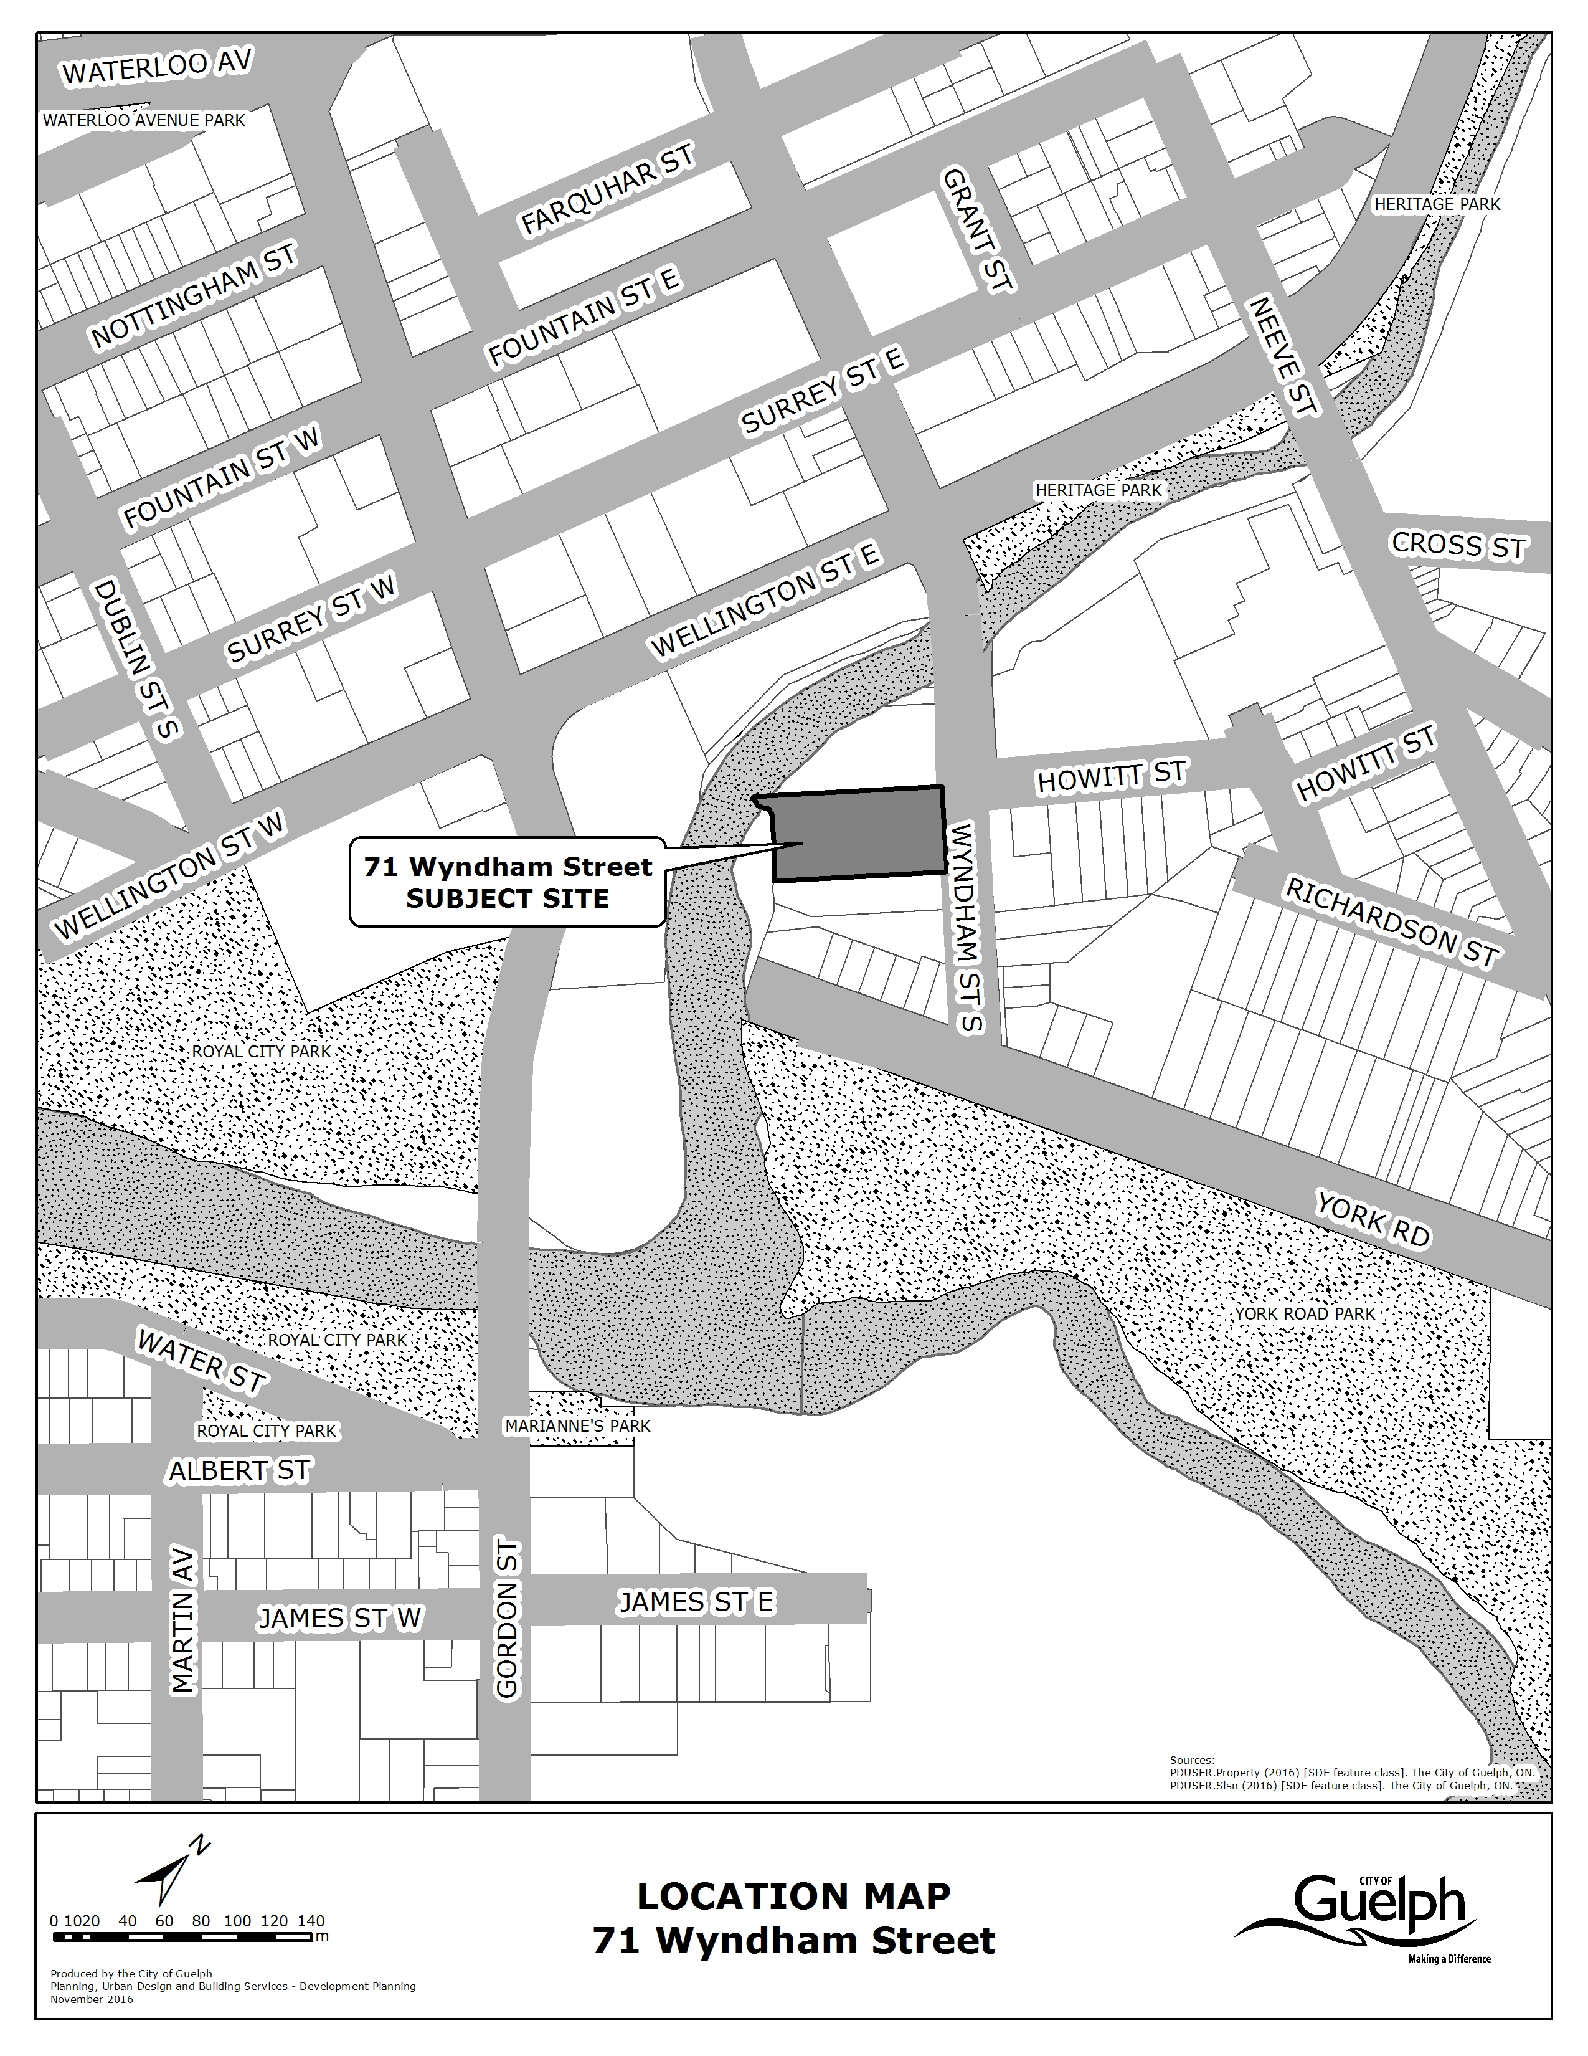
Attachment 2 – GRCA Comments
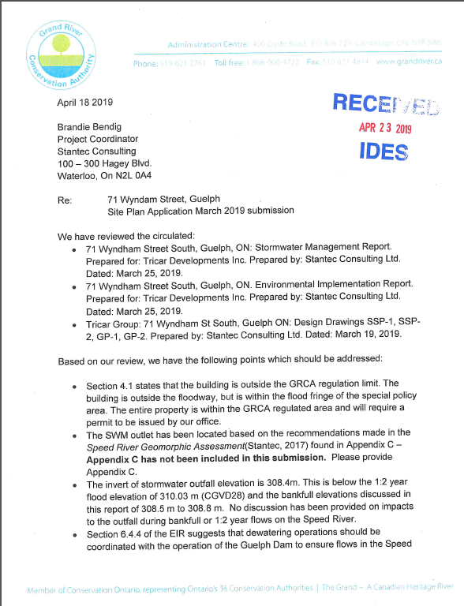
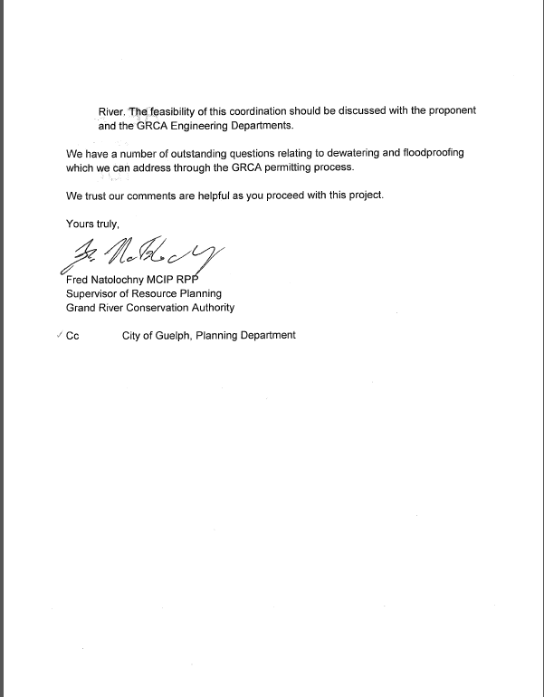

Attachment 3 – Parks Planning Comments


